Contents

**Appeals Regression** 2

**Current state:** 2

**UAT specification/Test criteria** 2

Regression: 2

**Full Appeal user journey** 3

Before you start: 3

# **Appeals Regression**

## **Current state:**

|  |  |
| --- | --- |
| **UAT specification/Test criteria/Test basis** | **none** |
| **Regression suite** | **none** |
| **Traceability matrix** | **none** |

## **UAT specification/Test criteria**

The appeals service currently has no documented specification for how it should behave. The service has had tickets created against work products, but no specification was established before these tickets were created. This can lead to ambiguities and incorrect implementation of behaviour.

Example: some appeal types can have a deadline of 12 weeks or 6 months. 6 months can pass or fail depending on the year (leap), or the month you begin with when you calculate the date, or even the date calculator you use. The date calculator that passes the 12 weeks did not pass the 6 months. The 6 months should have a specified equivalent of either weeks or days in the specification.

The tickets can be used for traceability but because of the evolution of the pages within the service, the tickets will have to be checked to determine which best describes the current functionality. This does however, run the risk of embedding any possible errors within the final criteria when retrospectively creating requirements from legacy tickets. This risk will be mitigated by reviewing with SME’s and team leads.

## Regression:

The regression suite will be created against the requirements specification. The scope will be system level functional tests. Non-functional tests may be added later.

## Traceability Matrix:

The mapping for the traceability matrix will be created in the usual way, providing a mapping from specification and its associated work product, and an executable test.

# **Full Appeal user journey**

## Before you start:

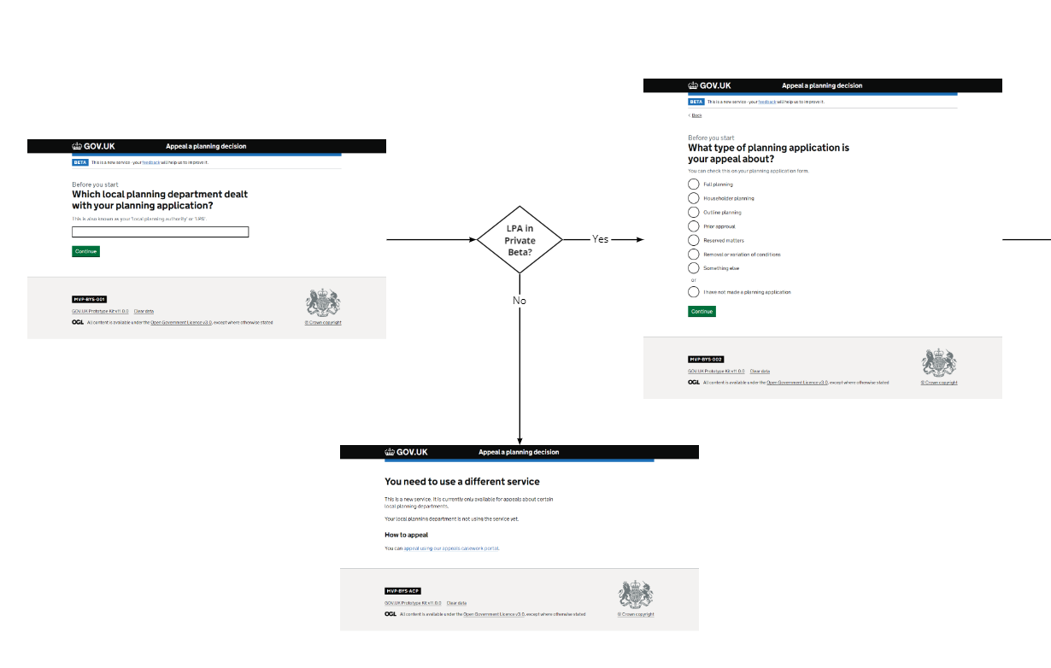

Householder appeal user journey: